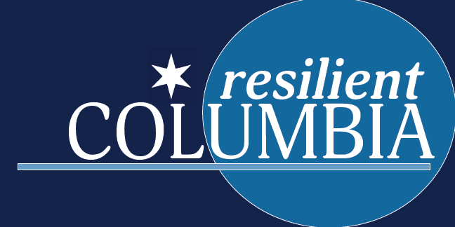
Columbia Incident Response Brief
(Reporting data as of July 23, 2020)
Situational Update
- 4,054,407 Confirmed Cases in the U.S. with 144,469 total deaths
- 76,315 Confirmed and 291 Probable Cases in SC, all 46 Counties reporting, 1,294 confirmed deaths with an additional 40 Probable in our state
  - 1,538 new cases with an additional 5 Probable cases as of midnight last night
20.9% Positive Test Rate
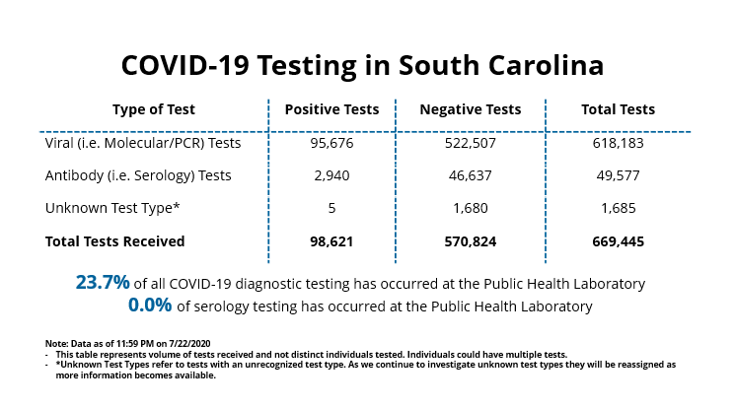
Source: SC DHEC
https://www.scdhec.gov/infectious-diseases/viruses/coronavirus-disease-2019-covid-19/sc-testing-data-projections-covid-19

- Richland County
  - 6,577 Confirmed Cases with an additional 110 Probable in Richland County, 120 deaths
    - 138 new cases reported on July 23rd
    - Highest Zip Codes activity can be found on the COVID Zip Code PDF provided. (Charleston, Greenville, Horry, Richland, and Lexington counties reporting the highest cumulative totals)
    - City GIS dashboard tracking cases in Richland County by zip code
      - COVID-19 Cases Dashboard: https://colacitygis.maps.arcgis.com/apps/opsdashboard/index.html#/69407604f8114ab880b97b04dea113f1

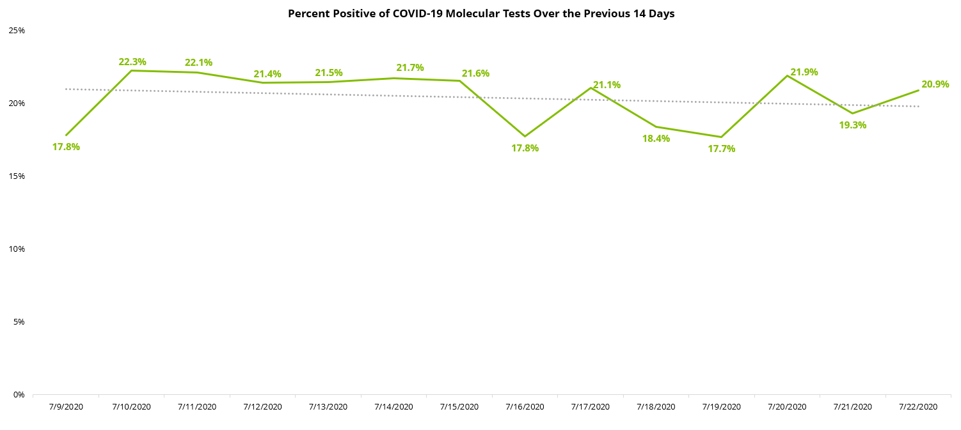
Source: SC DHEC
https://www.scdhec.gov/infectious-diseases/viruses/coronavirus-disease-2019-covid-19/sc-testing-data-projections-covid-19

SC DHEC Testing Dashboard
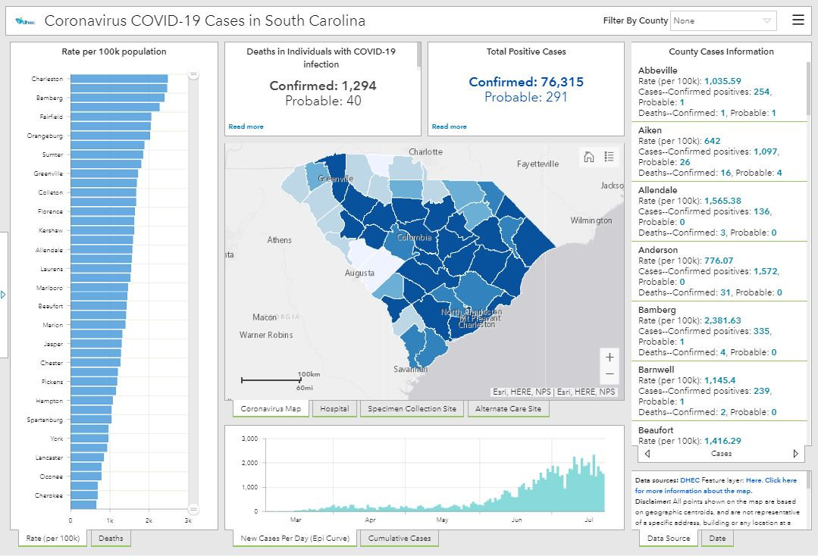
Source: SC DHEC
https://www.scdhec.gov/infectious-diseases/viruses/coronavirus-disease-2019-covid-19/sc-testing-data-projections-covid-19
New Daily Cases in Richland County – City GIS Dashboard

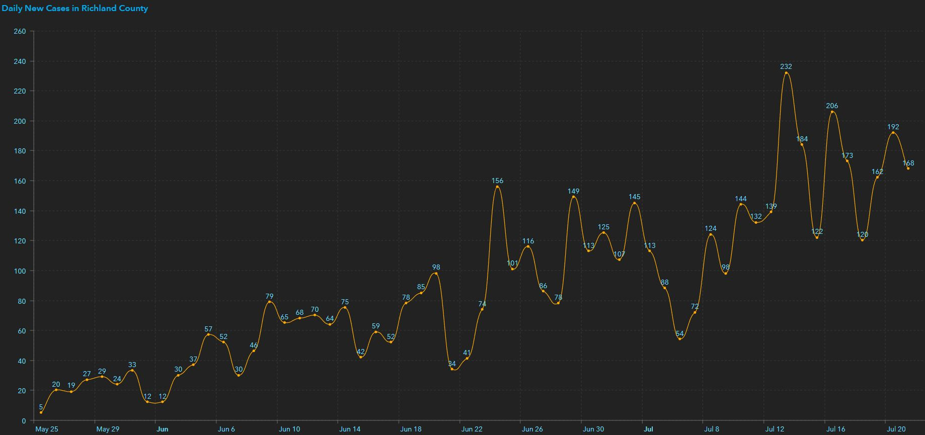
City of Columbia GIS COVID-19 Cases Dashboard: https://colacitygis.maps.arcgis.com/apps/opsdashboard/index.html#/69407604f8114ab880b97b04dea113f1

- Hospitals
  - 4,425 total hospital beds available and 7,998 are in use; 64.38% statewide total hospital bed utilization rate
  - 1,723 COVID-19 patients are currently hospitalized
  - 1,458 Ventilators, 532 are in use and 241 of those are COVID-19 patients
  - 1,522 inpatient beds are available and 9,961 are in use, which is an 86.7% statewide hospital bed utilization rate
  - 76.6% in Richland county (836 beds occupied with 256 available)
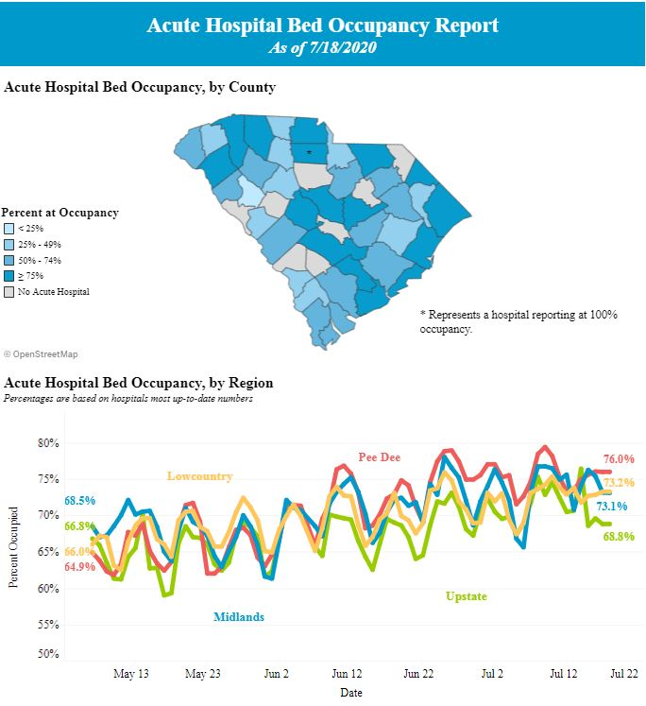
Source: SC DHEC
https://www.scdhec.gov/infectious-diseases/viruses/coronavirus-disease-2019-covid-19/hospital-bed-capacity-covid-19
City of Columbia Internal Updates/Efforts
Employee PPE
- Contracts & Procurement has provided masks and PPE to departments
- The Fulfillment Center continues to process requests and has sufficient PPE stocks on hand in inventory
Office of Business Opportunities
- SBSF Loan Program - 880 Applications In Portal
- To date, we have awarded 323 small businesses, totaling $1,400,000 (All Funds Allocated)
Resilient Columbia (RC)
- 296 businesses that have taken the pledge
Mask Up
- 4 Departments are currently serving as Ambassadors (Code Enforcement, Customer Care, Parks & Recreation, and Parking Services)
- All are reporting having good educational opportunities with the general public and customers
- A high degree of compliance has also been observed
- Over 760 contacts made to date
Distribution of Protective Masks to Citizens
- 15,559 protective masks have been distributed over a two-week period
- Week of June 29 – July 3
  - 3,090 Busby Street Community Center
  - 721 Hampton Park Neighborhood Center
  - 2,049 Earlewood Community Center
  - 1,014 S. Edisto Neighborhood Center
  - 6,874 Total
- Week of July 6 – July 10
  - 6,605 Busby Street Community Center
  - 1,866 Hampton Park Neighborhood Center
  - 4,846 Earlewood Community Center
  - 2,242 S. Edisto Neighborhood Center
  - 8,685 Total
Mask Ordinance
- Fire Marshal’s continue to educate businesses and citizens on the importance of using masks and the requirements of the Mask Ordinance
- They are seeing generally overall good compliance
- 93 visits to date
- 87 contacts where educational materials were provided
- 180 individual masks have been provided to the general public by DFM’s
- 10 warnings have been issued
- 5 Citations have been issued to date
- No individual citations issued
Safety & Risk Assessments
- 46 Risk Assessments of City facilities and departments have been completed by Safety & Risk Management
- 2 External Risk Assessments have been completed with our external partners
- These Risk Assessments are ongoing
- Department of Safety & Risk Management/HR composed and implemented a COVID-19 Safety Disinfectant & Cleaning Your Living and Work areas for all employees on the City of Columbia Inner City Intranet Site.
City Facilities Mitigations/Modifications
- Support Services continues to ensure daily cleaning of City facilities
- 178 preventive cleanings have been conducted
- Constructed 101 protective barriers
- Installed 232 signs
- Social distancing mitigations have also been implemented at 1136 Washington Square to include all elevators
Disinfecting and Sanitizing Operations
- Departments continue to clean facilities, offices, workstations and highly touched areas
- Safety & Risk Management continue to provide guidance and monitor operations to ensure effective sanitizing and disinfecting occurs on a frequent basis
Public & Media Relations
Public Relations, Media and Marketing continues to handle both crisis communications and public information duties on a daily basis. Daily website updates and social media posts are a priority for COVID-19 information and modified City operations.
Please see the latest press releases and media advisories for specific details below.
- City Council Meeting | Tuesday, July 21, 2020
https://columbiasc.gov/headlines/07-20-2020/CityCouncilMeetingTuesdayJuly21
- City of Columbia Receives 2020 Municipal Achievement Award
https://columbiasc.gov/headlines/07-22-2020/CityofColumbiaReceives2020MunicipalAchievementAward
Website and Microsite Updates:
- Mask Ordinance FAQs
- Mask Complaints information
- Mask Ordinance
- July Testing sites
Media Relations/Requests:
- Inquiry from WLTX on an interview about the status of the cooling/misting stations for the summer.
Social Media Updates:
- COVID 19 July Testing sites.
- #Maskup Contest
- POTW
- New Partners for #Maskup Contest
- City Wins MASC award
- Mask safety tips
- Deadline for vacancies on boards and commission
Video Content:
- PR updated the COVID-19 testing video with July dates.
- PR staff recorded a message/speech from the City Manager to the CFD firefighter recruits for their upcoming graduation ceremony.
Zoom Operations:
- City Council Meeting | Tuesday, July 21, 2020

